Descendants of James Redpath Falconer & Elizabeth Nichol

Prepared and submitted by Al Falconer.
Email: falconer@tnt21.com
Web Page: http://home.tnt21.com/~falconer

1. James Redpath Falconer, born 18-May-1821 in Bellsquarry, Mid-Calder, Scotland, (son of George Falconer and Janet Redpath) baptized __-___-1821 in West Calder Secession Congregation, died 8-Feb-1901 in Kinloss Township, Bruce, ON, buried 12-Feb-1901 in South Kinloss Presbyterian Cemetery, Lucknow, ON, resided in Kinloss Township, Bruce, ON.
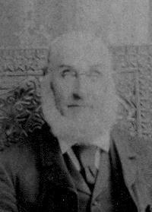

He married (1) Elizabeth Nichol, married 13-May-1847 in Zorra Township, Oxford, ON, married in Brock District., born 30-Nov-1828 in Roxburgh, Scotland, died 8-Jun-1890 in Traill County, ND, buried in Quincy, Traill, ND.
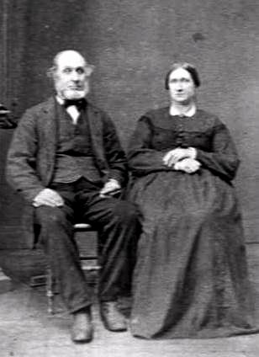

Children:

2. i. George W. Falconer born 21-May-1849.

3. ii. Margaret Falconer born 17-Apr-1852.

4. iii. Janet Redpath Falconer born 20-Jul-1855.

5. iv. Thomas Falconer born 16-Jul-1858.

v. Elizabeth Falconer, born 4-Dec-1860 in Kinloss Township, Bruce, ON, died 14-Dec-1860 in Kinloss Township, Bruce, ON, buried in South Kinloss Presbyterian Cemetery, Lucknow, ON, resided in Kinloss Township, Bruce, ON.
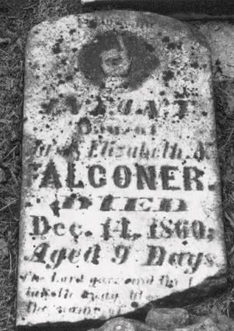

vi. James Falconer, born 6-Nov-1861 in Kinloss Township, Bruce, ON, baptized 28-Jun-1863 in South Kinloss Presbyterian Church, Lucknow, ON, died 22-Jun-1868 in Kinloss Township, Bruce, ON, buried in South Kinloss Presbyterian Cemetery, Lucknow, ON, resided in Kinloss Township, Bruce, ON.
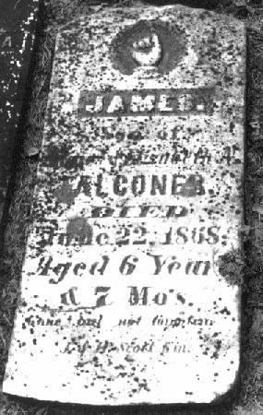

vii. John Alexander Falconer, born 15-Jun-1863 in Kinloss Township, Bruce, ON, died Before 1871 in Kinloss Township, Bruce, ON, buried in South Kinloss Presbyterian Cemetery, Lucknow, ON, resided in Kinloss Township, Bruce, ON.

6. viii. Elizabeth Falconer born 17-Apr-1864.

7. ix. Helen Falconer born 13-Sep-1866.

He married (2) Margaret Ann Cantwell, married 24-Dec-1891 in Lucknow, Bruce, ON, born 26-Mar-1856 in Ashfield Township, Huron, ON, (daughter of Patrick Cantwell and Catherine Gibson) died __, resided in Kinloss Township, Bruce, ON.
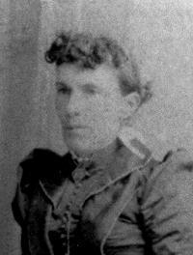

Second Generation

2. George W. Falconer, also known as George A., born 21-May-1849 in Stanley Township, Huron, ON.

He married (1) Katherine Armstrong, married in ON, born __-___-185_ in Canada, died __-___-1878, buried in Quincy, Traill, ND.

Children:

i. Tina Falconer.

ii. Alice Falconer, resided in Moorhead, Clay, MN.

iii. Ellen Falconer, also known as Nellie, born __-___-1873 in Canada, resided __-___-1880 in Traill County, ND.

iv. Elizabeth Falconer, born __-___-1877 in Canada, resided __-___-1880 in Traill County, ND.

He married (2) Margaret C. Nichol, also known as Nicoll, married 23-Jan-1885 in ND, born in Canada, resided __-___-1913 in Tacoma, Pierce, WA.

Children:

v. Myrtle M. Falconer, born 27-Jun-1889 in ND, died 19-Mar-1913 in Florence, Pinal, AZ, buried 21-Mar-1913 in Tacoma, Pierce, WA.

- Margaret Falconer, born 17-Apr-1852 in Stanley Township, Huron, ON, died 18-Mar-1924 in Clearwater County, MN, buried in Leonard, MN.
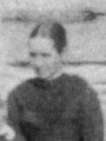

She married John Falconer, married 3-Feb-1874 in Kinloss Township, Bruce, ON, born 25-Oct-1849 in Stanley Township, Huron, ON, (son of James Falconer and Jane Johnson) died 30-Sep-1932 in Clearwater County, MN, buried in Leonard, MN.
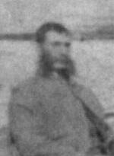

Children:

8. i. Elizabeth Nichol Falconer born 31-Oct-1874.

ii. James Alexander Falconer, born 15-Aug-1877 in Kinloss Township, Bruce, ON, died 21-Aug-1965 in Clearwater County, MN, buried in Leonard, MN.
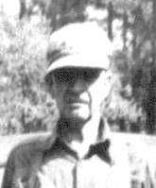

iii. Thomas George Falconer, born __-Jan-1880 in Kelso Township, Traill, ND, died __-___-1950, buried in Fargo, Cass, ND.

- Adam Douglas Falconer, born 6-Jun-1883 in Kelso Township, Traill, ND, died 14-Feb-1958 in Clearwater County, MN, buried in Leonard, MN.
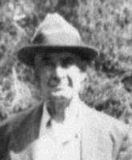

- John Simon Falconer, born 9-Aug-1886 in Kelso Township, Traill, ND, died 18-Apr-1953 in Clearwater County, MN, buried in Leonard, MN.
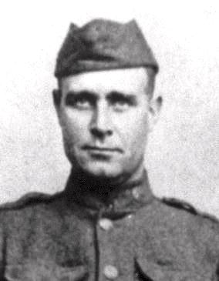

- Jane Helen Falconer, born 13-Sep-1888 in Kelso Township, Traill, ND, died 30-Aug-1889, buried in Quincy, Traill, ND.
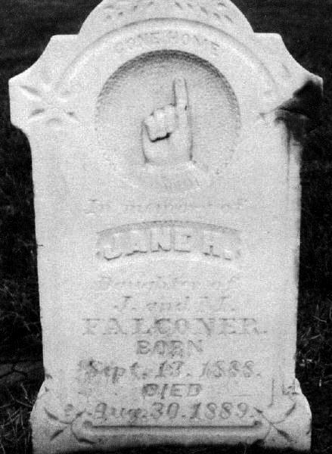

9. vii. Charles Cable Falconer born 14-Oct-1891.

- Janet Redpath Falconer, born 20-Jul-1855 in Kinloss Township, Bruce, ON, died 30-Dec-1932, buried in Roseville, CA.
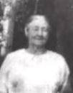

She married Alexander Falconer, married 14-Oct-1873 in Kinloss Township, Bruce, ON, born 20-Aug-1847 in Stanley Township, Huron, ON, (son of James Falconer and Jane Johnson) died 26-Jul-1937, buried in Roseville, CA, naturalized 5-Dec-1888 in Cass County, ND.
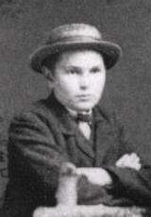

Children:

10. i. James H. Falconer born 1-Aug-1874.

ii. George William Falconer, born 7-Feb-1878 in ND, died 13-Nov-1952 in Placer County, CA, buried in Roseville, CA, occupation Jockey.

11. iii. Elizabeth Jane Allison Falconer born 26-Apr-1880.

- Margaret Ellen Falconer, also known as Nellie, born 21-Dec-1882 in ND, died 7-Jul-1910, buried in Roseville, CA, resided in Roseville, CA.
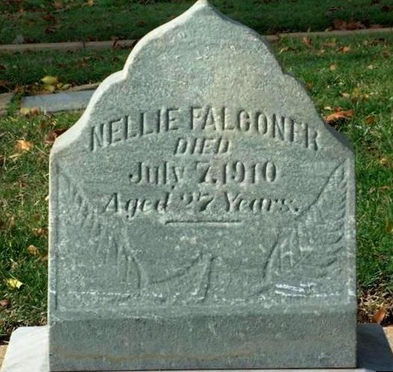

v. Allan Herman Falconer, born 30-Nov-1884 in ND, died 2-Apr-1971 in Sacramento County, CA, resided in San Jose, Santa Clara, CA, occupation Cement Business.
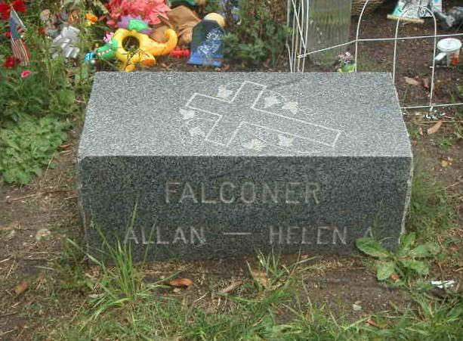

He married Helen A.

vi. William Alexander Falconer, born 7-Sep-1888 in ND, died 21-Dec-1940 in Placer County, CA, buried in Roseville, CA.

He married (UNKNOWN).

vii. Leroy Leonard Falconer, born 28-Dec-1893 in Roseville, CA, died 22-Jul-1956 in Napa County, CA, buried in Golden Gate Nat. Cem., San Bruno, CA.

5. Thomas Falconer, born 16-Jul-1858 in Kinloss Township, Bruce, ON, baptized 28-Jun-1863 in South Kinloss Presbyterian Church, Lucknow, ON, died __, resided in Grandin, Cass, ND.

He married Mary Douglas, also known as Mayme, married 15-Mar-1887 in Elm River, Traill, ND, born 27-Sep-1864 in ND, (daughter of Douglas and Nichol) died 31-May-1958 in Los Angeles County, CA, resided in Glendale, Los Angeles, CA.

Children:

i. Raymond Falconer, resided in Minneapolis, Hennepin, MN.

ii. Douglas Falconer.

iii. Harry Falconer.

iv. Elsie Mae Falconer, died 14-Jun-1915 in Pine County, MN.

v. Marion Elizabeth Falconer, also known as Bessie, born 18-Aug-1902 in Douglas County, MN, died 15-Apr-2001 in Silverdale, WA, resided in Poulsbo, Kitsap, WA, never married.

6. Elizabeth Falconer, born 17-Apr-1864 in Kinloss Township, Bruce, ON, baptized 25-Oct-1868 in South Kinloss Presbyterian Church, Lucknow, ON, died __-___-1931 in Silverton, Marion, OR, buried in Silverton Cemetery, Marion, OR.

She married John Nicol, married 18-Mar-1881 in Fargo, Cass, ND, born __-___-1855, resided in Silverton, OR, died __-___-1928 in Silverton, Marion, OR, buried in Silverton Cemetery, Marion, OR.

Children:

i. Agnes Nicol, born __-___-1882 in ND.

ii. William Nicol, born __-___-1884 in ND.

7. Helen Falconer, also known as Ellen, born 13-Sep-1866 in Kinloss Township, Bruce, ON, baptized 25-Sep-1868 in South Kinloss Presbyterian Church, Lucknow, ON, died __-___-1942 in Fargo, Cass, ND, buried in ND, resided in ND.

She married John Herman, married __-___-1886 in Quincy, Traill, ND, married in Johnson Hotel, divorced __-___-1903, born 15-Jul-1857 in ON, (son of Hiram Herman and Catherine Callan) died 18-Jan-1923 in Long Beach, Los Angeles, CA, buried in Inglewood Park Cemetery, Inglewood, CA.

Children:

i. John Franklin Herman, also known as Frank, born __-Jul-1887 in ND, died __ in Stockton, San Joaquin, CA.

- Albert Granville Herman, also known as Bert, born __-Oct-1889 in
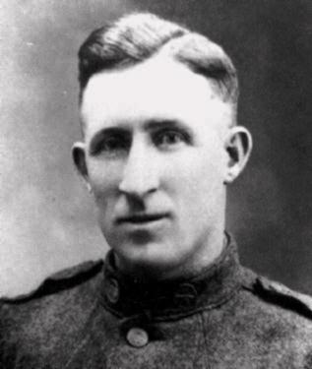

ND, died __-___-1948.

iii. Annie M. Herman, born __-May-1892 in ND, died __-___-1926.

iv. Elizabeth Herman, also known as Bessie, born 22-Nov-1894 in Kelso Township, Traill, ND, died 5-Nov-1895 in Kelso Township, Traill, ND, buried __-Nov-1895 in Quincy, Traill, ND.

Third Generation

- Elizabeth Nichol Falconer, born 31-Oct-1874 in Kinloss Township, Bruce, ON, baptized __-Oct-1875 in South Kinloss Presbyterian Church, Lucknow, ON, died 29-Oct-1948 in Fargo, Cass, ND, buried in Quincy, Traill, ND.
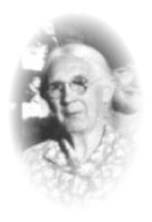

She married James Alexander Johnson, married 14-Nov-1894 in Traill County, ND, born __-Jan-1869 in Varna, Huron, ON, (son of James Johnson and Anna Sparling) died __-Jan-1928, buried in Near Unwin, AB, resided __-___-1924 in Lloydminster, AB.
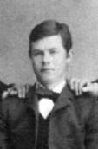

Children:

i. Edith Johnson, born 18-Apr-1895 in Grandin, Cass, ND, died 6-May-1978 in Norman County, MN, buried in Quincy, Traill, ND, resided in Ada, Norman, MN.
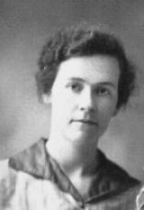

She married Pleasant Martin Hess, born __-___-1886, died 5-May-1953 in Hennepin County, MN, buried in Quincy, Traill, ND.
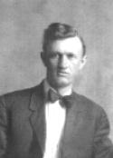

ii. Mary Ellen Johnson, born __-Aug-1896 in ND, died __-Mar-1937, buried in Oxville Cemetery, McLaughlin, AB.
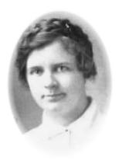

She married William Harrison.

iii. Ernest Wesley Johnson, also known as Wesley, born 25-Nov-1897 in Elm River, Traill, ND, died 2-Apr-1969 in Hendrum, Norman, MN, buried in Immanuel Lutheran Cemetery, Hendrum, MN.
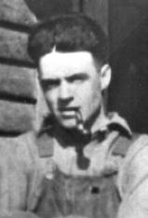

He married Minnie Dyrendahl, married 30-Nov-1924 in Ada, Norman, MN, born 29-Apr-1901 in Hendrum, Norman, MN, (daughter of Kristian Dyrendahl and Emelie Stegavig) died 7-Feb-1999, buried in Immanuel Lutheran Cemetery, Hendrum, MN, resided in Hendrum, Norman, MN.
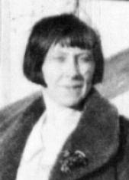

- Anne Frances Johnson, also known as Johnny, Fran, born 8-May-1900 in ND, died 15-Mar-1973, buried in Crescent City, CA.
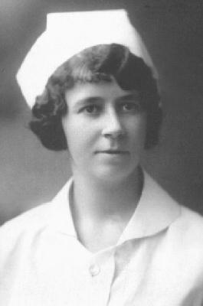

She married Raymond Wadsworth, also known as Tommy, born 24-May-1901, died __-May-1969, buried in Crescent City, CA.
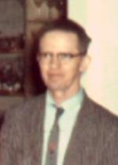

- Charlotte Pearl Johnson, born 25-Sep-1902, died 5-Aug-1939, buried in Edmonton, AB.
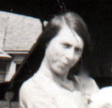

She married William Newey.
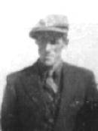

- Henry James Johnson, also known as Harry, born __-___-1905, died 3-Aug-1924, buried in Quincy, Traill, ND.
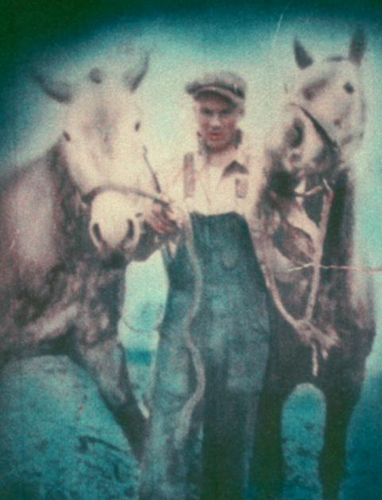

vii. Thomas Everett Johnson, born 9-Aug-1907, died __-___-1987, resided in Fargo, Cass, ND.
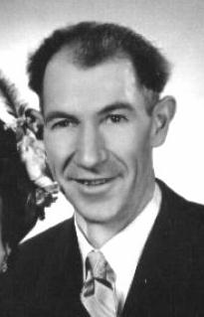

He married Anne Smithwicke, married __-Feb-1949.
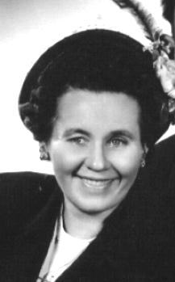

- Edna Winnifred Johnson, born 30-Aug-1909 in Elm River, Traill, ND, died 22-Apr-1964 in San Francisco, San Francisco, CA.
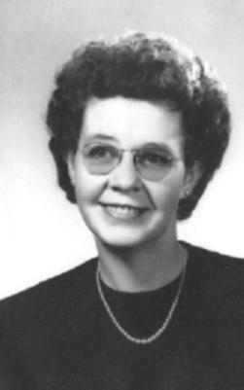

She married Nicolas Richard Mergenthaler.
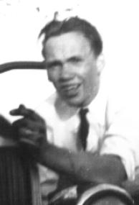

- Mildred June Johnson, born 23-Jun-1912 in Traill County, ND, died __-___-1976.
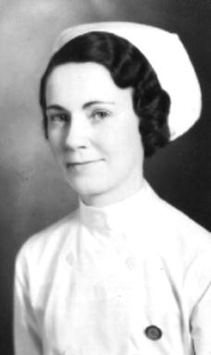

She married Lawrence Milton Graham, married 16-Jun-1937, born 3-Apr-1907.
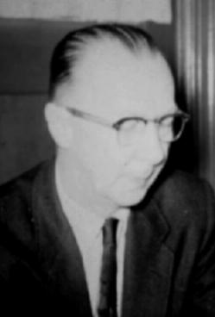

9. Charles Cable Falconer, born 14-Oct-1891 in Kelso Township, Traill, ND, died 5-Apr-1980, buried in Cypress Lawn Cem., Everett, WA.
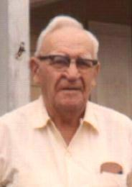

He married Ella Jeanette Stevens, married in Bemidji, MN, born 8-Dec-1894 in Duluth, St. Louis, MN, died __-Feb-1969 in WA, buried in Cypress Lawn Cem., Everett, WA, resided in Everett, Snohomish, WA.

Children:

i. Janet Marie Falconer, born in Bemidji, MN, resided in Everett, Snohomish, WA.
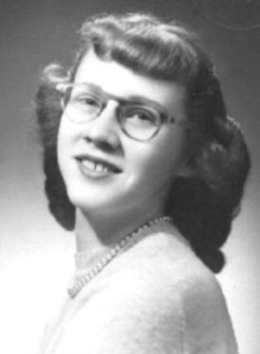

She married Delmar Clarence Thompson.

ii. Charlotte Alpha Falconer, born in Shevlin, MN, resided in Rock Island, IL.
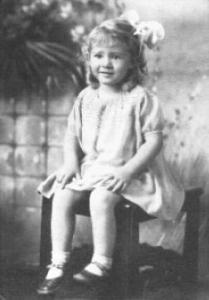

She married Nicolas James Stahair, married in Everett, Snohomish, WA, resided in Rock Island, IL.

10. James H. Falconer, birth name James Alexander, nickname "Good-feed Falconer", born 1-Aug-1874 in Kinloss Township, Bruce, ON, died 19-Sep-1951 in Buckeye, Maricopa, AZ, buried 22-Sep-1951 in Double Butte Cemetery, Tempe, AZ.
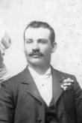

He married (1) Roxie Ellen Moore, also known as Roxie, married __-___-189_, born 25-Jan-1879 in IA, (daughter of John Moore and Mary Jane Shives) died 9-May-1968 in Sacramento County, CA, buried in East Lawn Cemetery, Foot Hill Farms, CA, resided in Roseville, CA.
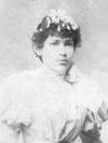

Children:

i. Son Falconer, born __-___-189_ in Placer County, CA, died at birth in Placer County, CA.

ii. Emmett Lawrence Falconer, born 24-Aug-1899, died 26-Sep-1993, resided in Sacramento, Sacramento, CA, buried in East Lawn Cemetery, Foot Hill Farms, CA.

He married Lillian Ida Stichmann, born in WI, (daughter of Stichman and Gordon) died 10-May-1984 in Sacramento County, CA, buried in East Lawn Cemetery, Foot Hill Farms, CA.

iii. Leland John Falconer, born 13-Mar-1901 in Lincoln, Placer, CA, died 5-May-1964 in Sacramento County, CA, buried in East Lawn Cemetery, Foot Hill Farms, CA.

He married Julia Mae Forbush, married 26-Oct-1919, born 11-Apr-1901 in Mason Valley, Lyon, NV, (daughter of Alvin Harry Forbush and Jane Josephine Warcup) died 27-Nov-1995 in Sacramento County, CA, buried in East Lawn Cemetery, Foot Hill Farms, CA.

iv. Hazel Irene Falconer, born 16-Jan-1904 in CA, died 15-Jun-1995 in Sacramento, Sacramento, CA, buried in East Lawn Cemetery, Foot Hill Farms, CA.

She married Leonard Falconer Kirby, birth name Cirby, born 14-Aug-1903 in Roseville, CA, (son of Thomas Leonard Cirby and Elizabeth Jane Allison Falconer) died 30-Jun-1981 in Foot Hill Farms, Sacramento, CA, buried in East Lawn Cemetery, Foot Hill Farms, CA.

v. Maxine Lorraine Falconer, born 25-Mar-1916 in Lincoln, Placer, CA, resided in Sacramento, Sacramento, CA.

She married (1) Stanley Wayne Brune, born 9-Mar-1914 in Odessa, WA, (son of Howard Wayne Brune and Olive Ladd Larrabee) died 26-Jul-2001 in Sacramento, Sacramento, CA.
She married (2) Malcolm Brandt, died __-___-1969.
She married (3) Mark Henderson.
She married (4) Albert Talkin.

He married (2) Ethel F., married in Phoenix, Maricopa, AZ, buried 19-Mar-1969 in Double Butte Cemetery, Tempe, AZ.
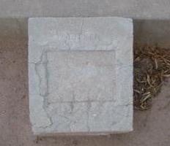

11. Elizabeth Jane Allison Falconer, also known as Bessie, born 26-Apr-1880 in Quincy, Traill, ND, died 19-May-1943 in Placer County, CA, buried in East Lawn Cemetery, Sacramento, CA.

She married Thomas Leonard Cirby, married 1-Jan-1900, born 9-Aug-1877 in Roseville, CA, (son of Cirby and Newingham) died 30-May-1955 in Placer County, CA.

Children:

i. Leonard Falconer Kirby, birth name Cirby, born 14-Aug-1903 in Roseville, CA, died 30-Jun-1981 in Foot Hill Farms, Sacramento, CA, buried in East Lawn Cemetery, Foot Hill Farms, CA.

He married Hazel Irene Falconer, born 16-Jan-1904 in CA, (daughter of James H. Falconer and Roxie Ellen Moore) died 15-Jun-1995 in Sacramento, Sacramento, CA, buried in East Lawn Cemetery, Foot Hill Farms, CA.

ii. Janet Ruby Cirby, born 1-Dec-1907 in Roseville, CA, died 15-Oct-1977 in Placer County, CA, buried in Roseville, CA.

She married John Richard Wittsche, married 26-Apr-1927, born 7-Sep-1906 in CA, (son of Wittsche and Arnold) died 29-Aug-1993 in Yolo County, CA, buried in Roseville, CA.

iii. Celia Ellen Cirby, born 30-Nov-1910 in Roseville, CA, died 8-Aug-1997, resided in Danville, Yell, AR.

She married Charles Ralph Schmitt.

